
实验报告
( 2023-2024 学年 第 一 学期 )

课 程 | 高级语言程序设计
院（系） | 计算机科学与技术学院
专 业 | 人工智能
级 别 | 2023级
学 号 | 2325191003
姓 名 | 陈一鸣
指导老师 | 李海波

实验五

一、实验目的和要求：
(1)练习数组。

二、实验设备：
PC机、Visual C++6.0、Dev C++或Blocks

三、实验原理及内容
1. 字符串的查找和替换。例如原文：
char str[]=” East China Normal University is very beautiful. I like East China Normal University very much. There is a big playground in East China Normal University. The teachers in East China Normal University are very kind. The students are very polite and smart.”;
要求输入一个字符串：Huaqiao University，替换掉原文中的East China Normal University
并且能够替换回来，即用East China Normal University替换掉Huaqiao University；
设计两个函数：搜索和替换，分别为search和replace。
数组和字符串的使用不受限制。

源程序代码如下（不要粘贴图片）
#include<iostream>
#include<string.h>
using namespace std;
int search(char str[], char ea[], int num)
{
int result;
for (int i = 0; i < num; i++)
{
result = -1;
if (str[i] == ea[0])
{
result = 1;
for (int j = 0; j < strlen(ea); j++)
{
if (str[i + j] != ea[j])
{
result = -1;
break;
}
}
}
if (result == 1) { return i; }
}
return -1;
}
void replace(char str[], char a[], char b[], int num, int x)
{
int c = strlen(a), d = strlen(b);
if (c > d) {
for (int i = x; i < num + d - c; i++)
{
str[i + d] = str[i + c];
}
}
else { {for (int i = num; i > x + c; i--) { str[i + d - c ] = str[i]; } }str[x + d] = ' ';
}
for (int i = 0; i < d; i++) { str[x + i] = b[i]; }
str[num + d - c] = '\0';
}
int main()
{
int search(char str[], char ea[], int num);
void replace(char str[], char a[], char b[], int num, int x);
char str[] = "East China Normal University is very beautiful.I like East China Normal University very much.There is a big playground in East China Normal University.The teachers in East China Normal University are very kind.The students are very polite and smart.";
char ea[] = "East China Normal University";
char hq[] = "Huaqiao University";
int num = strlen(str);
int x = search(str, ea, num);
do {
replace(str, ea, hq, num, x);
num = strlen(str);
x = search(str, ea, num);
} while (x != -1);
cout << "替换后的字符为" << '\n' << str << '\n';
int y = search(str, hq, num);
do {
replace(str, hq, ea, num, y);
num = strlen(str);
y = search(str, hq, num);
} while (y != -1);
cout << "重新替换回来的字符为" << str << endl;
return 0;
}
程序运行结果如下（粘贴截图）：
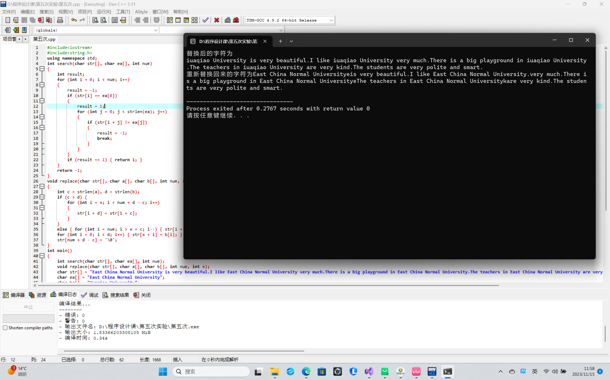

- 实验小结：
本次实验收到了徐嘉鼎同学的大力帮助，程序思路基本跟他是一样的。

